
ST RAFAEL SCHOOL I.E.D
NAME: __________________________________________ GROUP: 90__
DATE: _____________________

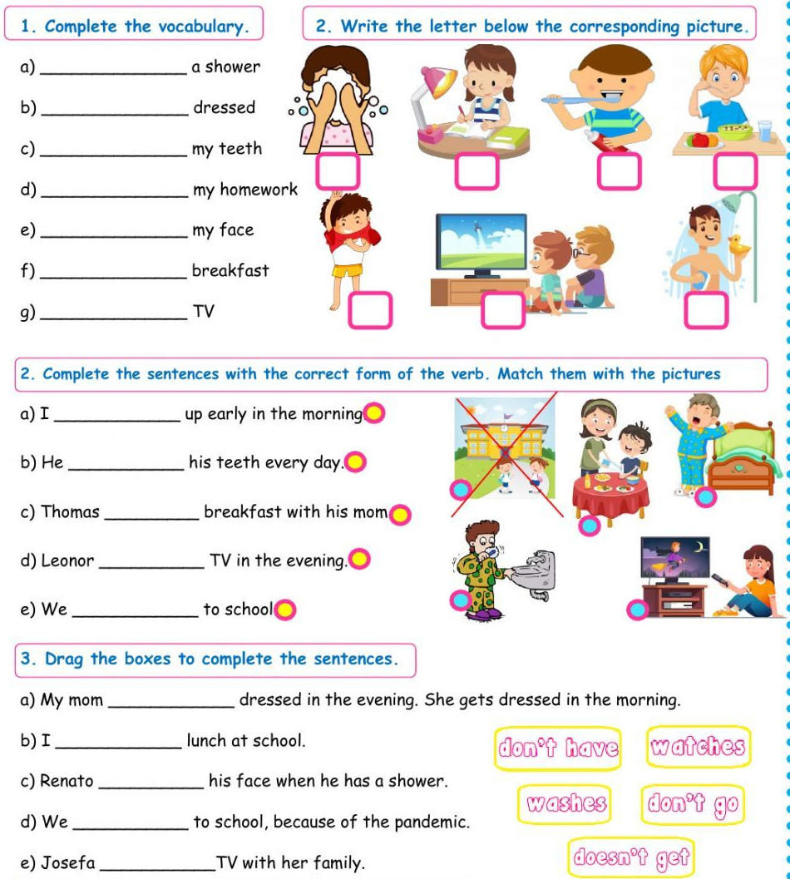
DAILY ACTIVITIES

