
 SAN RAFAEL SCHOOL
SIXTH GRADE ENGLISH WORKSHEET
FIRST TERM

NAME: _________________________________________________________ DATE: __________________

- PERSONAL INFORMATION

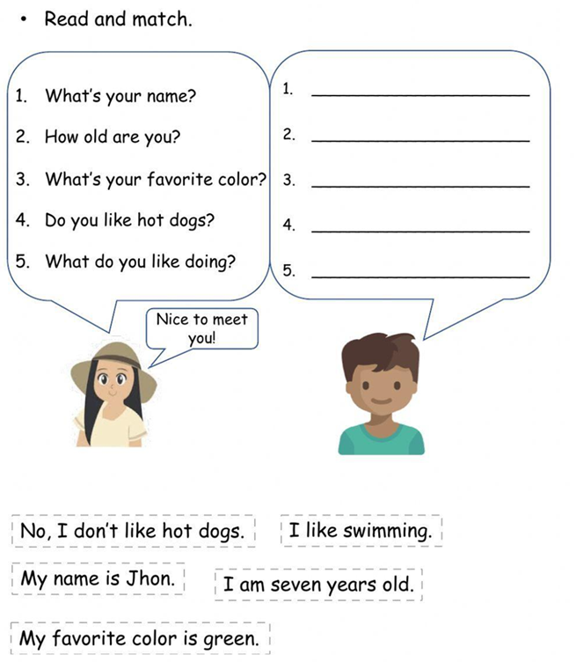

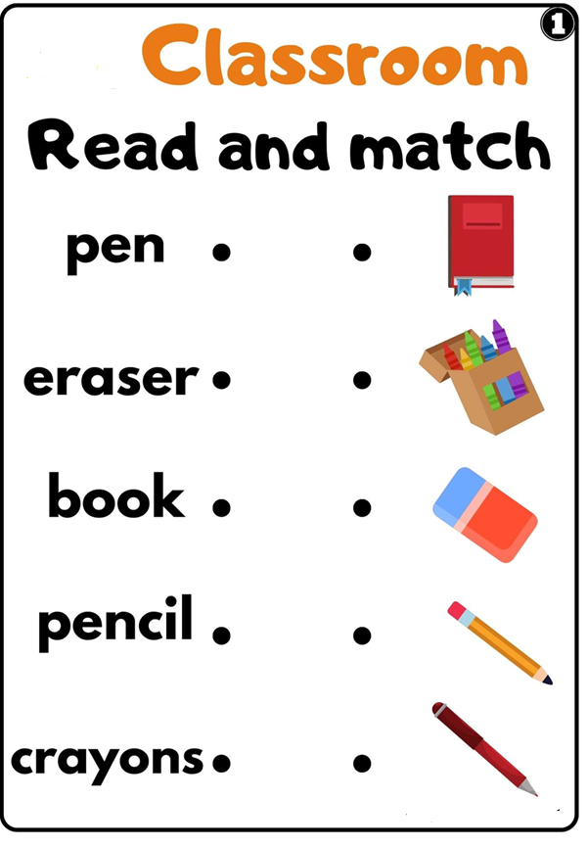

- Complete the following sentences with your own information. Then match the answers with the questions. Write the number on the line provided.

- My name is _________________________ ______ What do you do?
- I am ________ years old? _______ Where are you from?
- I am from ______________ _______ Where do you live?
- I live in ________________ _______ How old are you?
- I am _____________ _______ What´s your name?

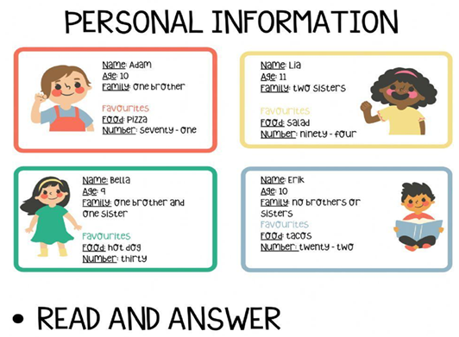

- What´s Lia´s favorite food?
- How old is Adam?
- What´s Bella´s favorite food?
- What´s Erik´s favorite number?
- How old is Bella?
- What´s Lia´s favorite number?
- How many siblings does Adam have?
- What´s Erik´s favorite food?
- How old is Lia?
- What´s Adma´s favorite food?

