COLEGIO SAN RAFAEL I. E. D.
SECRETARÍA DE EDUCACIÓN DE BOGOTÁ, D. C.
GUIA DE APOYO PRIMER TRIMESTRE 2024
ENGLISH – TENTH GRADE

Desempeño:
Realiza comparaciones de las maravillas del mundo antiguas y modernas, haciendo uso de los tiempos simples y perfectos, apreciando los diversos aportes culturales, y manifiesta su punto de vista de forma respetuosa, aceptando las diferencias frente a las practicas culturares y sociales, haciendo uso de los condicionales.

ACTIVITY

Read the following text about Marco and answer the questions:

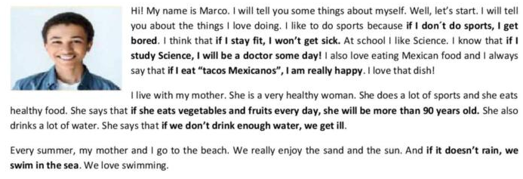
Figure 1Tomado de https://en.islcollective.com/english-esl-worksheets/grammar-practice/general-grammar-practice/conditionals/zero-and-first-conditional-reading-comprehension-and-worksheet-intermediate-students/149456

- Find in the text: zero conditional sentences (2) and first conditional sentences (2)

- Complete the uses of the conditionals with Zero conditional or First conditional:

We use ______________ to talk about real, future conditions and its probable result.

We use ______________ to talk about a certain consequence that is the result of another action.

- Complete the rules to form the conditionals.

Zero conditional

If + Subject + ___________________________, subject + _________________________________.

First conditional

If + Subject + ___________________________, subject + _________________________________.

- What is the text about?
- What happens if Marco doesn’t do sports?
- What will happen if Marco doesn’t stay fit?
- How does he feel if he eats Mexican tacos?
- According to Marcos’ mother, what will happen if she eats vegetables and fruits every day?
- According to Marcos’ mother, what happens if we don’t drink enough water?
- What do they do if it doesn’t rain in the beach?

- Complete these sentences about you and share your answers with a partner.

